Creating tow S3 bracket:- 1)source ,2)destination

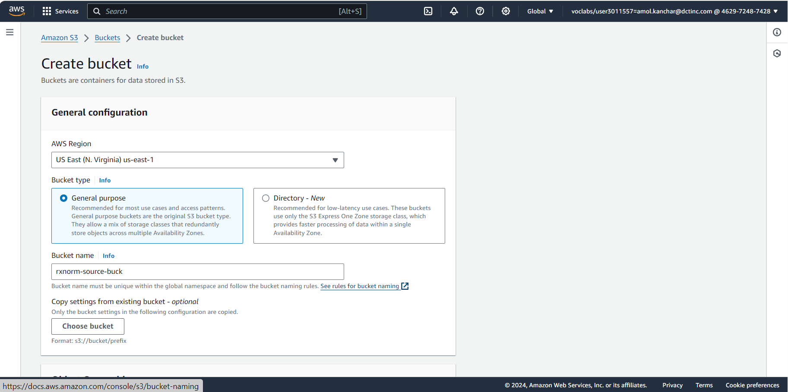

Creating folders in source bucket:-

Creating lambda function:-

Adding Trigger

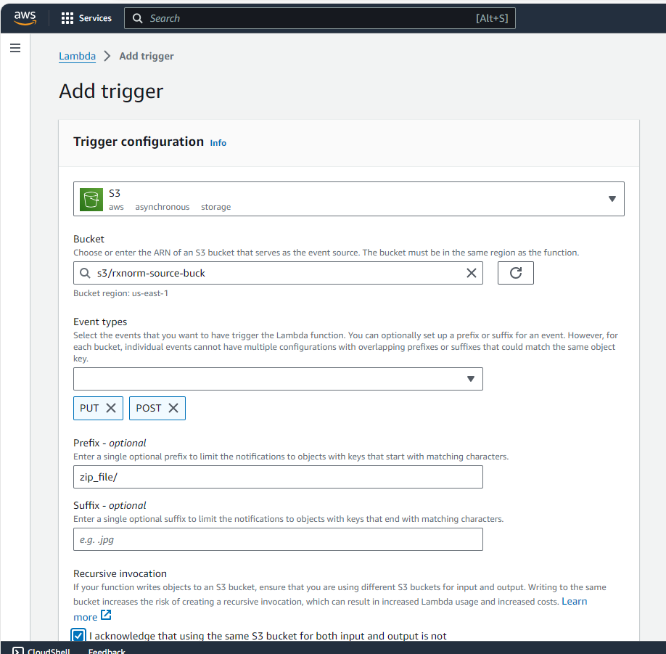

Adding pandas layer:-

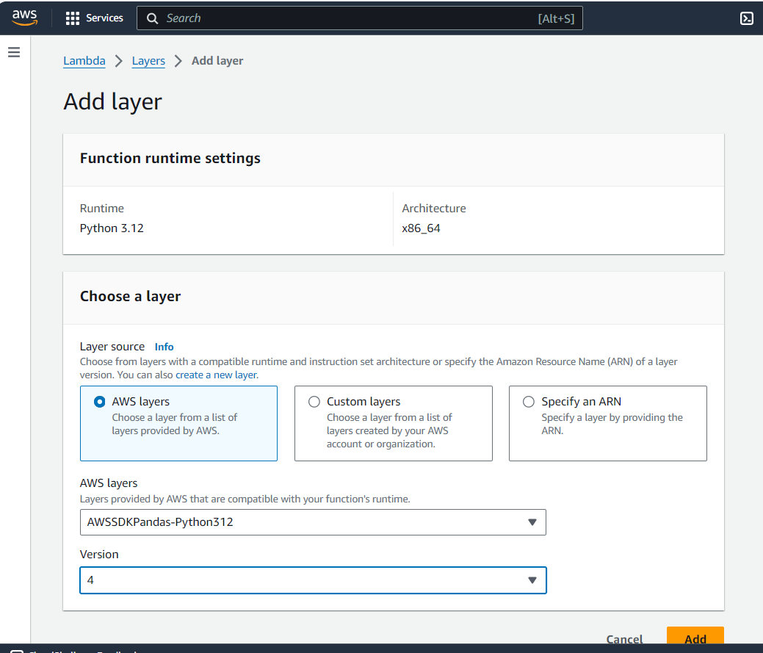

Changing Configuration Settings:-

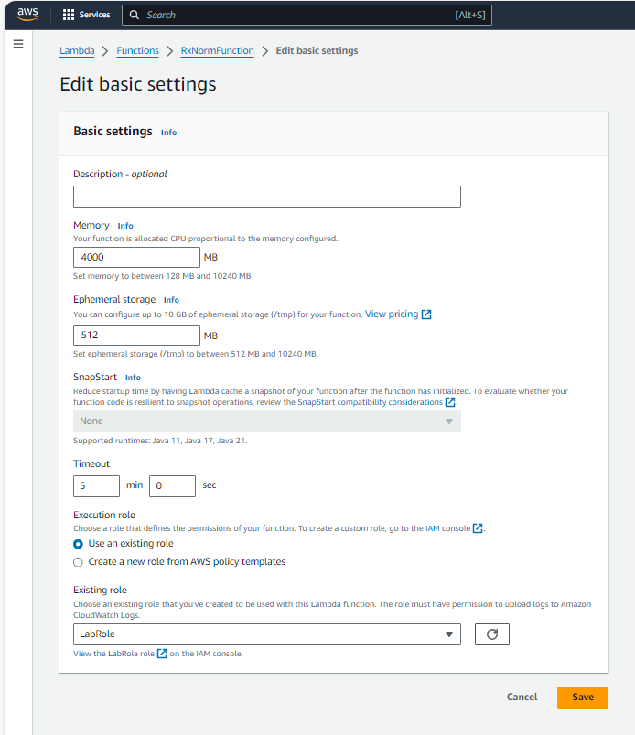

Code:-

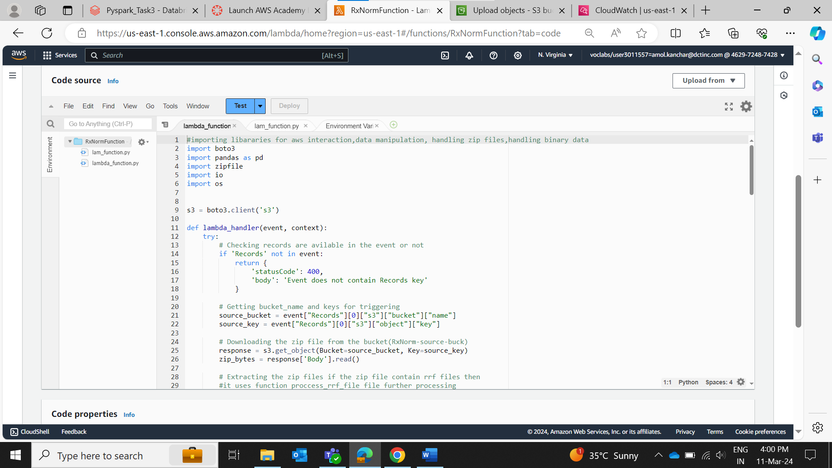

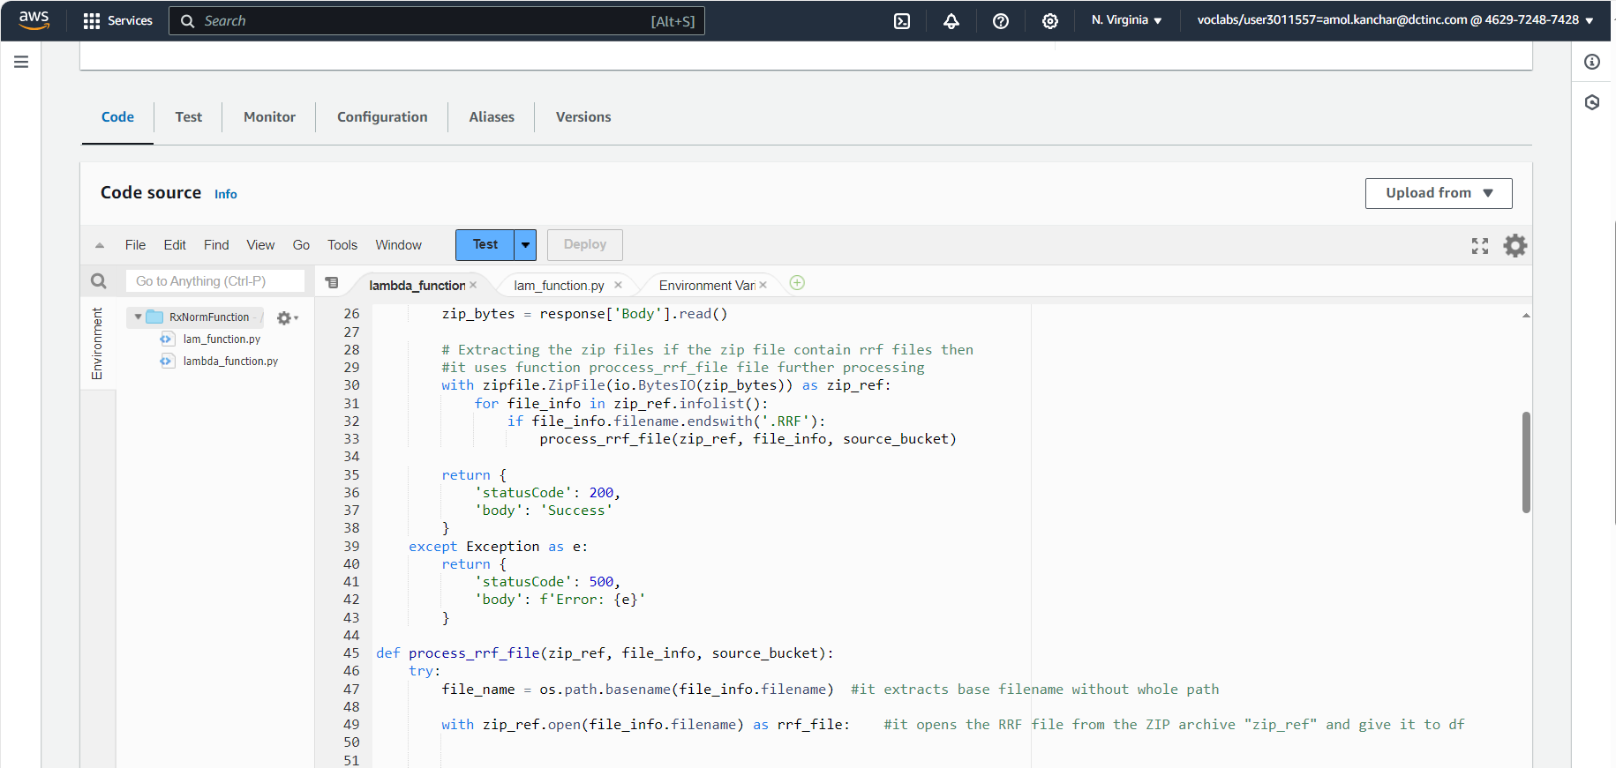

Adding header file in header_folder:-

Adding zip file in zip_folder:-

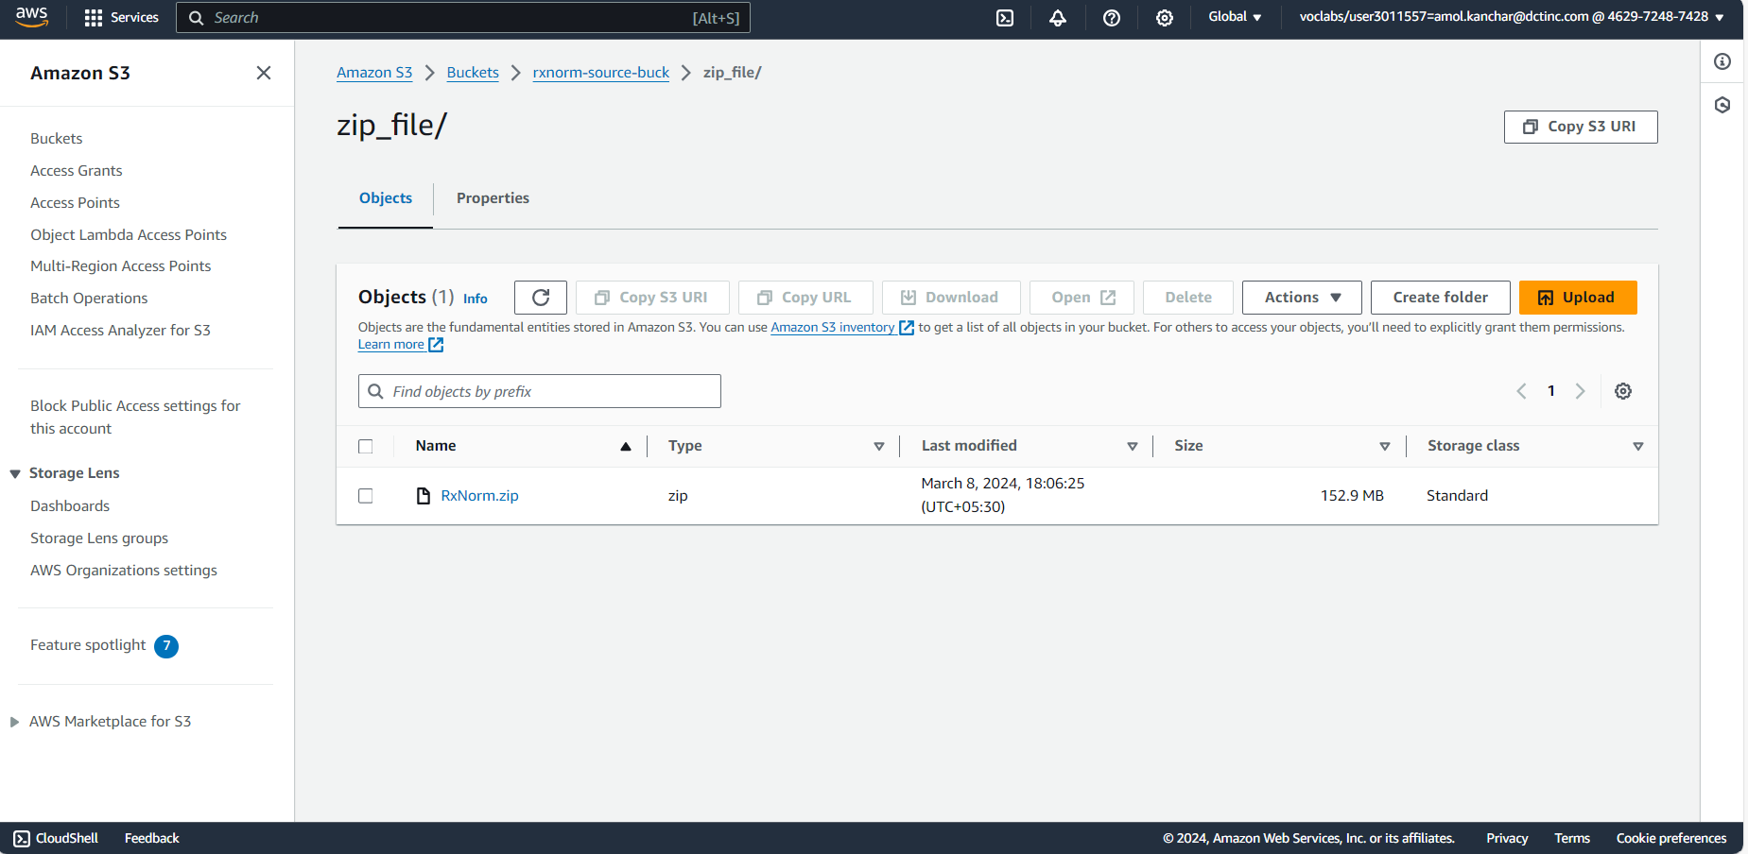

CloudWatchLog Result Validating row count:-

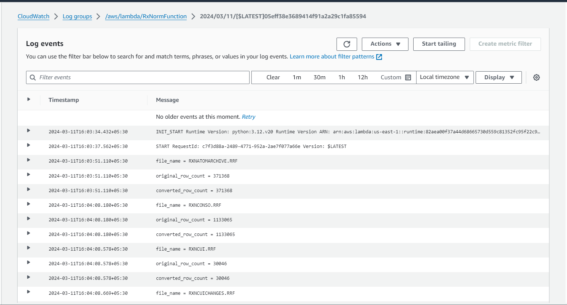

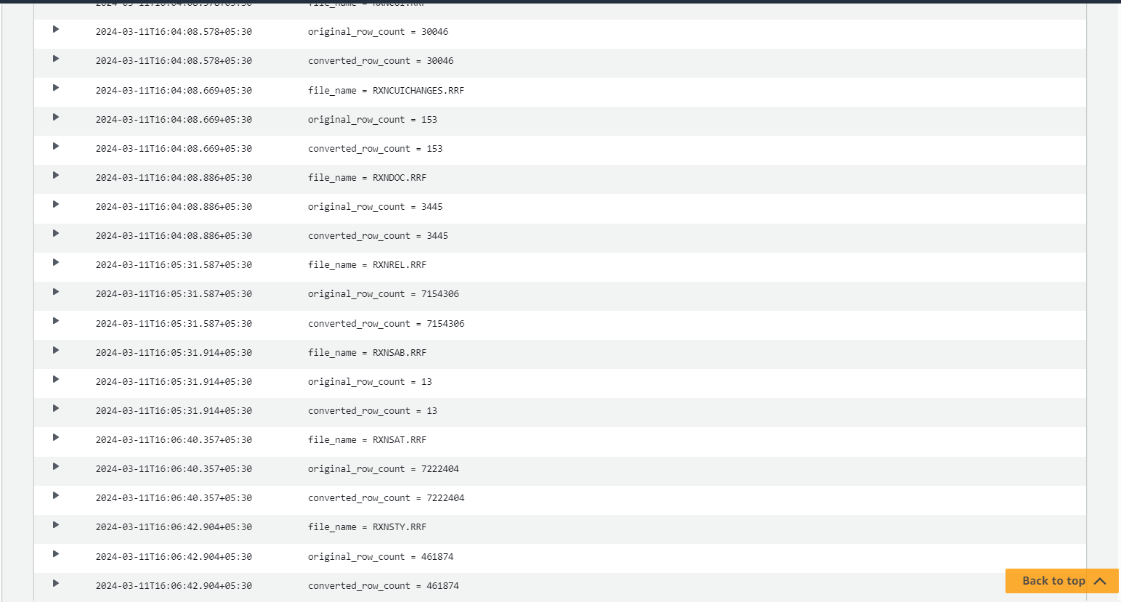

Destination Bucket with converted csv files:-

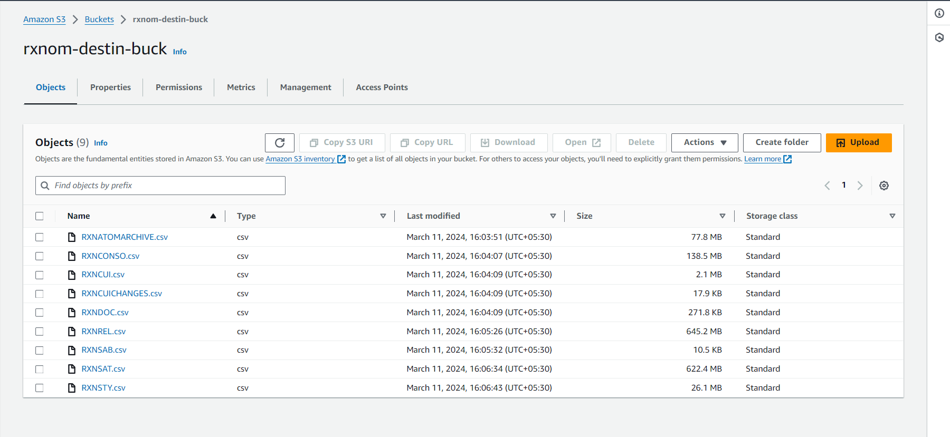

Sample file :-

RXNATOMARCHIEVE

Before Changes:-

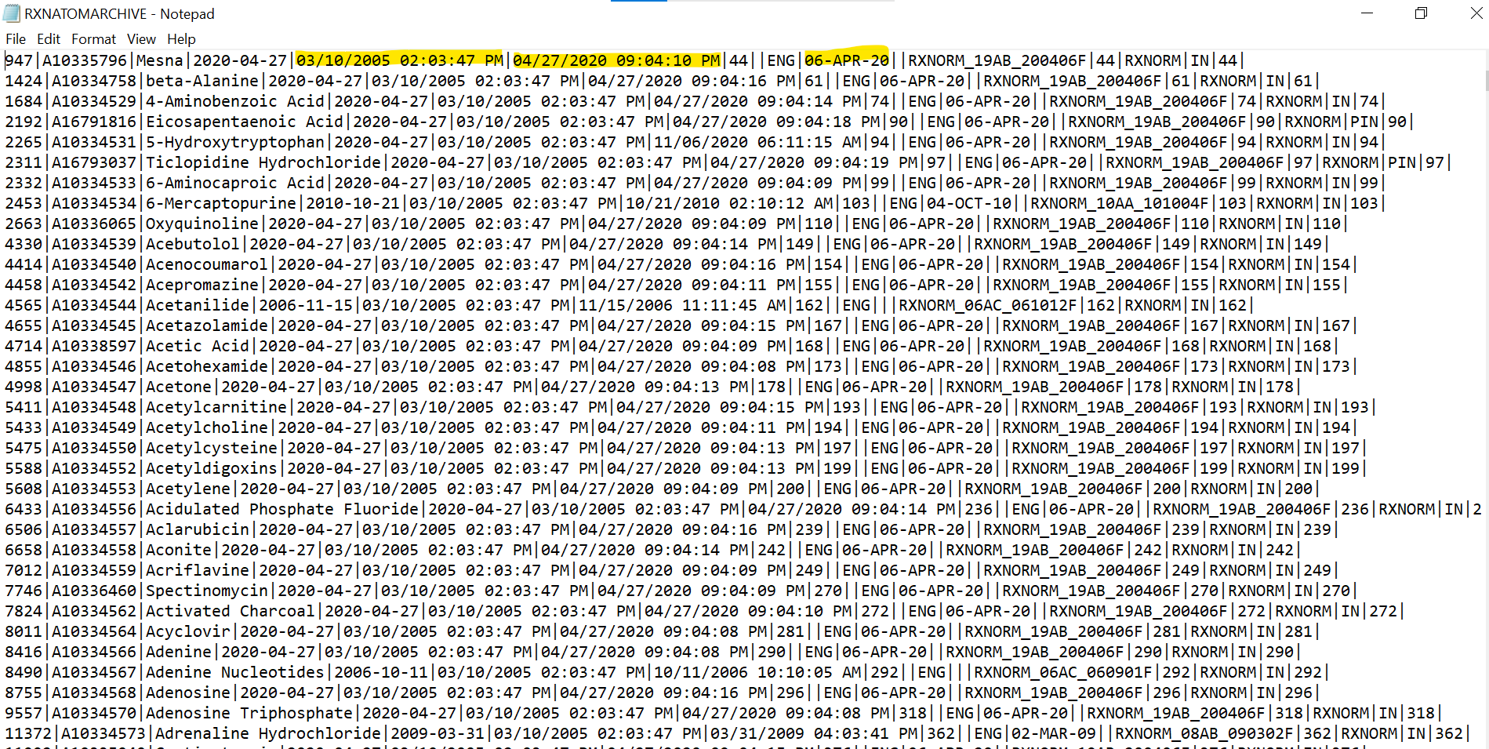

After Changes

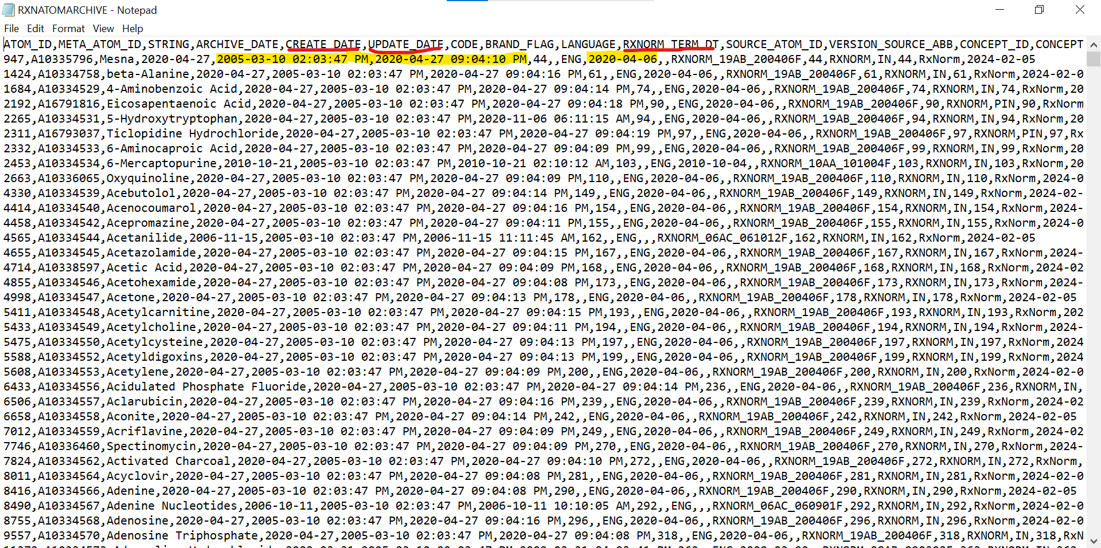

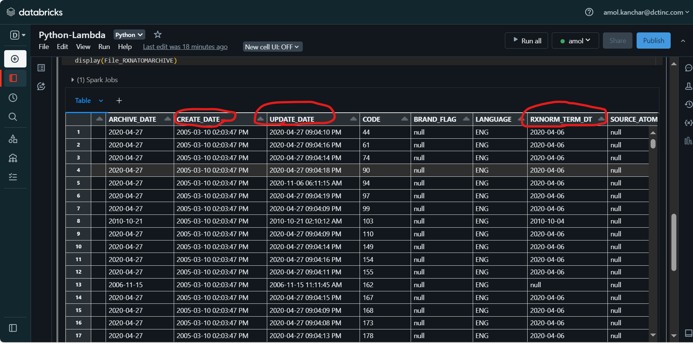

RXNSAB

Before Changes:-

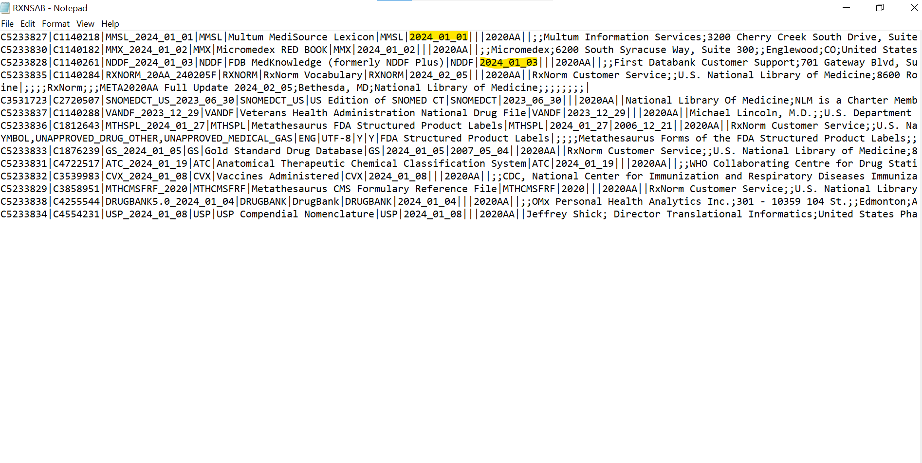

After Changes

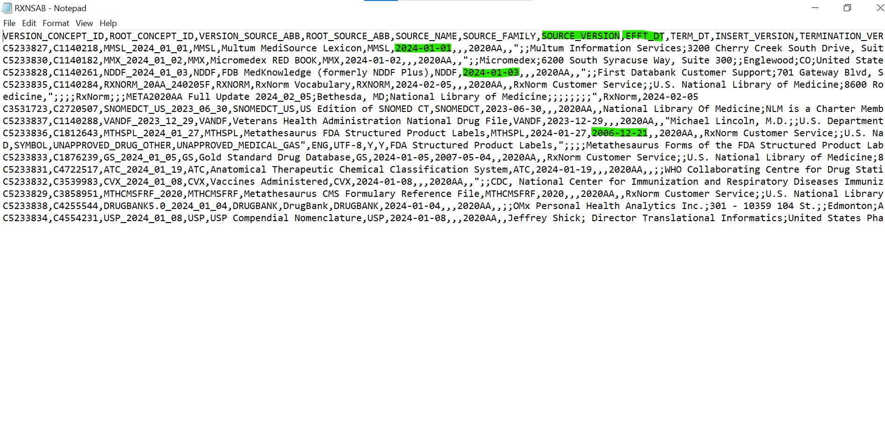

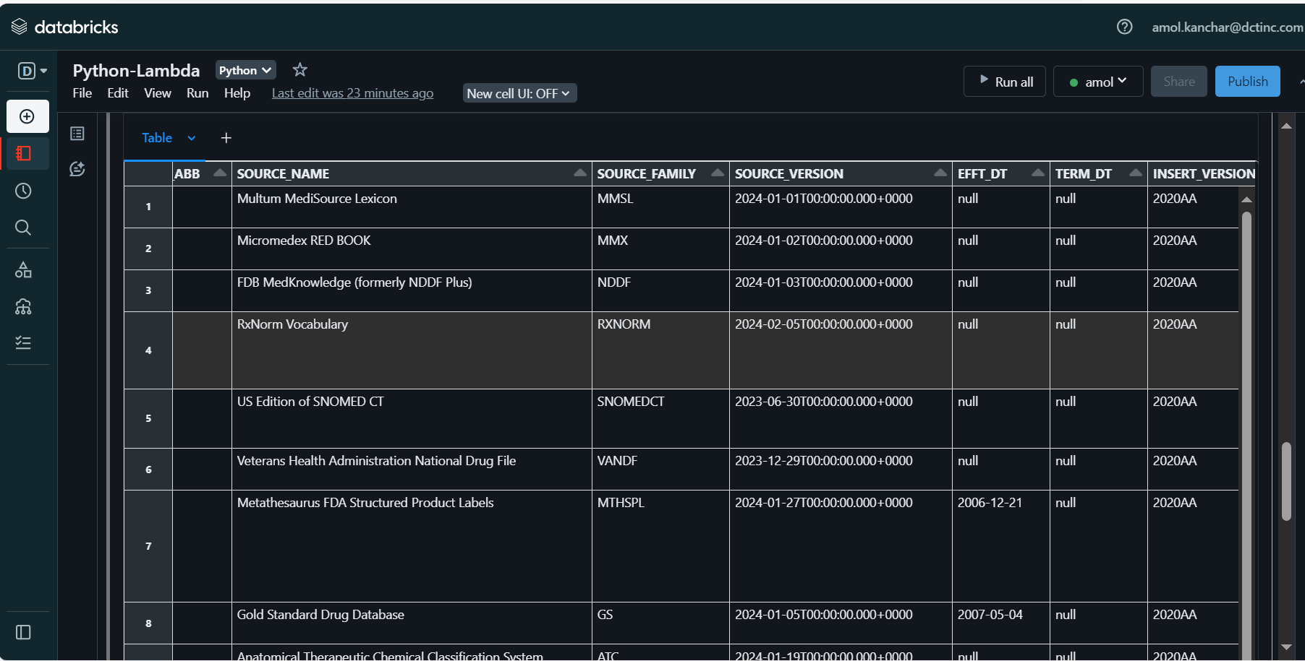

CODE_SET, VERSION_MONTH



